
08
Fall
Compassion
Righteousness
Knowledge
Loving Of
Kindness Faith God
Law Forever

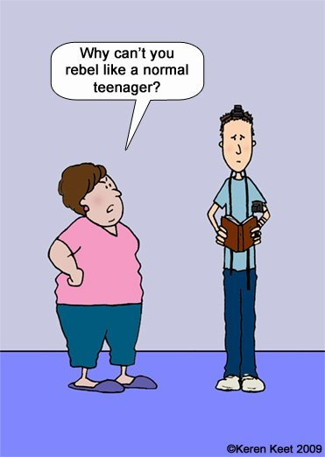
World Wide Wrap
Even Good Kids Need Positive Reinforcement.

World Wide Wrap

